USE pizza;

SELECT * FROM pizza_sales;

DESC pizza_sales;

UPDATE pizza_sales

SET order_date=str_to_date(order_date,"%d-%m-%Y");

ALTER TABLE pizza_sales

MODIFY order_date date;

-- **TOTAL REVENUE**

SELECT SUM(total_price) total_revenue FROM pizza_sales;

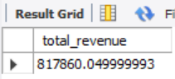

**-- AVERAGE ORDER VALUE**

SELECT (SUM(total_price)/COUNT(DISTINCT order_id)) avg_order_value

from pizza_sales;

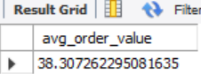

**-- TOTAL PIZZAS SOLD**

SELECT SUM(quantity) total_pizzas_sold FROM pizza_sales;

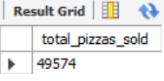

**-- TOTAL ORDERS**

SELECT COUNT(DISTINCT order_id) total_orders FROM pizza_sales;

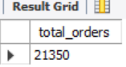

**-- AVERAGE PIZZAS PER ORDER**

SELECT ROUND(SUM(quantity)/COUNT(DISTINCT order_id),2) avg_pizzas_per_order from pizza_sales;

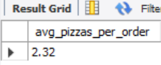

**-- DAY TREND FOR TOTAL ORDERS**

SELECT DAYNAME(order_date) day, COUNT(DISTINCT order_id) total_orders from pizza_sales

GROUP BY DAYNAME(order_date);

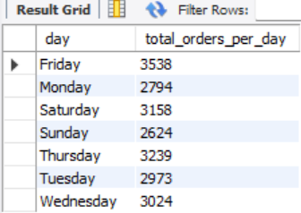

**-- MONTHLY TREND FOR TOTAL ORDERS**

SELECT MONTHNAME(order_date) month, COUNT(DISTINCT order_id) total_orders from pizza_sales

GROUP BY MONTHNAME(order_date);

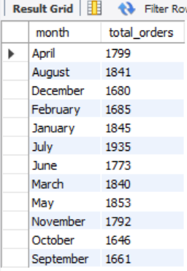

**-- PERCENTAGE OF SALES BY PIZZA CATEGORY**

SELECT pizza_category,ROUND(SUM(total_price),2) total_sales,

ROUND(100* SUM(total_price)/ (SELECT SUM(total_price) FROM pizza_sales),2) PCT from pizza_sales

GROUP BY pizza_category;

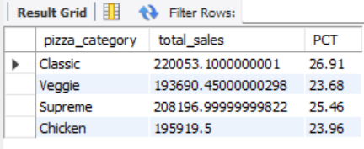

**-- PERCENTAGE OF SALES BY PIZZA SIZE**

SELECT pizza_size,ROUND(SUM(total_price),2) total_sales,

ROUND(100* SUM(total_price)/ (SELECT SUM(total_price) FROM pizza_sales),2) PCT from pizza_sales

GROUP BY pizza_size

ORDER BY pizza_size;

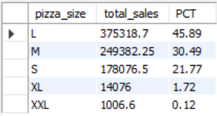

**-- TOTAL PIZZAS SOLD BY PIZZA CATEGORY**

SELECT pizza_category, SUM(quantity)total_pizzas_sold from pizza_sales

GROUP BY pizza_category

ORDER BY total_pizzas_sold desc;

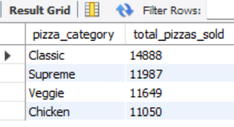

**-- TOP 5 PIZZAS BY REVENUE**

SELECT pizza_name,

SUM(total_price) total_revenue

FROM pizza_sales

GROUP BY pizza_name

ORDER BY total_revenue desc

LIMIT 5;

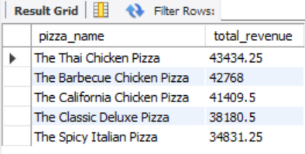

**-- BOTTOM 5 PIZZAS BY REVENUE**

SELECT pizza_name,

ROUND(SUM(total_price),2) total_revenue

FROM pizza_sales

GROUP BY pizza_name

ORDER BY total_revenue

LIMIT 5;

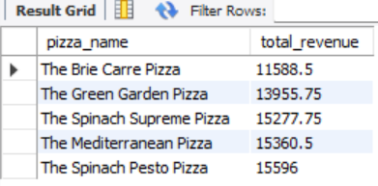

**-- TOP 5 PIZZAS BY QUANTITY**

SELECT pizza_name,

SUM(quantity) total_quantity

FROM pizza_sales

GROUP BY pizza_name

ORDER BY total_quantity desc

LIMIT 5;

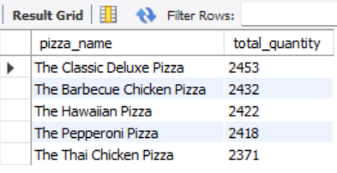

**-- BOTTOM 5 PIZZAS BY QUANTITY**

SELECT pizza_name,

SUM(quantity) total_quantity

FROM pizza_sales

GROUP BY pizza_name

ORDER BY total_quantity

LIMIT 5;

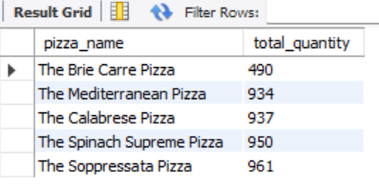

**-- BOTTOM 5 PIZZAS BY TOTAL ORDERS**

SELECT pizza_name,

COUNT(DISTINCT order_id) total_orders

FROM pizza_sales

GROUP BY pizza_name

ORDER BY total_orders

LIMIT 5;

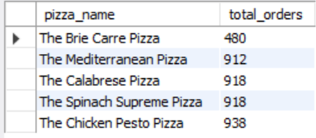

**-- TOP 5 PIZZAS BY TOTAL ORDERS**

SELECT pizza_name,

COUNT(DISTINCT order_id) total_orders

FROM pizza_sales

GROUP BY pizza_name

ORDER BY total_orders desc

LIMIT 5;

